

* ***Table of content***

***Information*** 3

**1.1.** **About Us** 3

**1.2.** **Roles** 3

***For the site*** 4

***Future Ideas*** 6

***Functions*** 9

**Information**

# **About Us**

The participants in our project are:

* Kamelia Yaneva, 9th grade;

e-mail :[KKYaneva19@codingburgas.bg](mailto:KKYaneva19@codingburgas.bg)

* Petya Petkova 9th grade;

e-mail :[PIPetkova19@codingburgas.bg](mailto:PIPetkova19@codingburgas.bg)

* Vesela Dekova 9a class;

e-mail :[VBDekova19@codingburgas.bg](mailto:VBDekova19@codingburgas.bg)

* Polina Petrova 9b class;

e-mail :[PYPetrova19@codingburgas.bg](mailto:PYPetrova19@codingburgas.bg)

# **Roles**

* Kamelia Yaneva – Scrum Trainer
* Petya Petkova – Back-End Developer
* Vesela Dekova – Designer
* Polina Petrova – Front-End Developer

**For the site**

The theme of our site is about the fire department.

Our home page contains a button to a small page about our team, a button to the menu, two forms, that send their data to our email and a button to the “Contact us” page.

When you go on the menu, we see the pages divided into columns.

In the first column there are two sections- the first one is named “Пожарни центрове” and the second-“Интересно“.

The first section contains of three pages: one that has explanation about the teams that work in the fire department, second that gives information about the cars and third about the fire extinguishers in the fire department.

The second section - “Интересно“, has one page that contains news about the fire department in Burgas.

The second column has three sections. The first one is named “Събитие“ and has a page where you can report an accident, by giving the exact hour, day, address and GPS coordinates or just contact the fire department by the given phones, email or even their Facebook page.

The second section – “Местоположение“, contains information about the address and a map.

The third section - “Контакти” has one page where you can find the telephones, email, and the address of the fire department so that you can contact them.

The last column has two main sections.

The first one has information presented with three pie chart statistics. On the bottom of the site there is also a legend that explains the colors used in the statistics.

The second section has four mini sites that give information and advice on how to deal with different accidents. For example, the first one is about what to do if there is an earthquake, the second- about firs, the third is about floods and the last one-about car crashes.

The last page we made is located in the upper left corner of each of our pages. This page gives short information about our team. It’s linked using the static logo.

**Future Ideas**

**Our future ideas are:**

1. To improve the logo
2. To make a motion logo
3. To add more shapes
4. To change the design
5. To use a form database

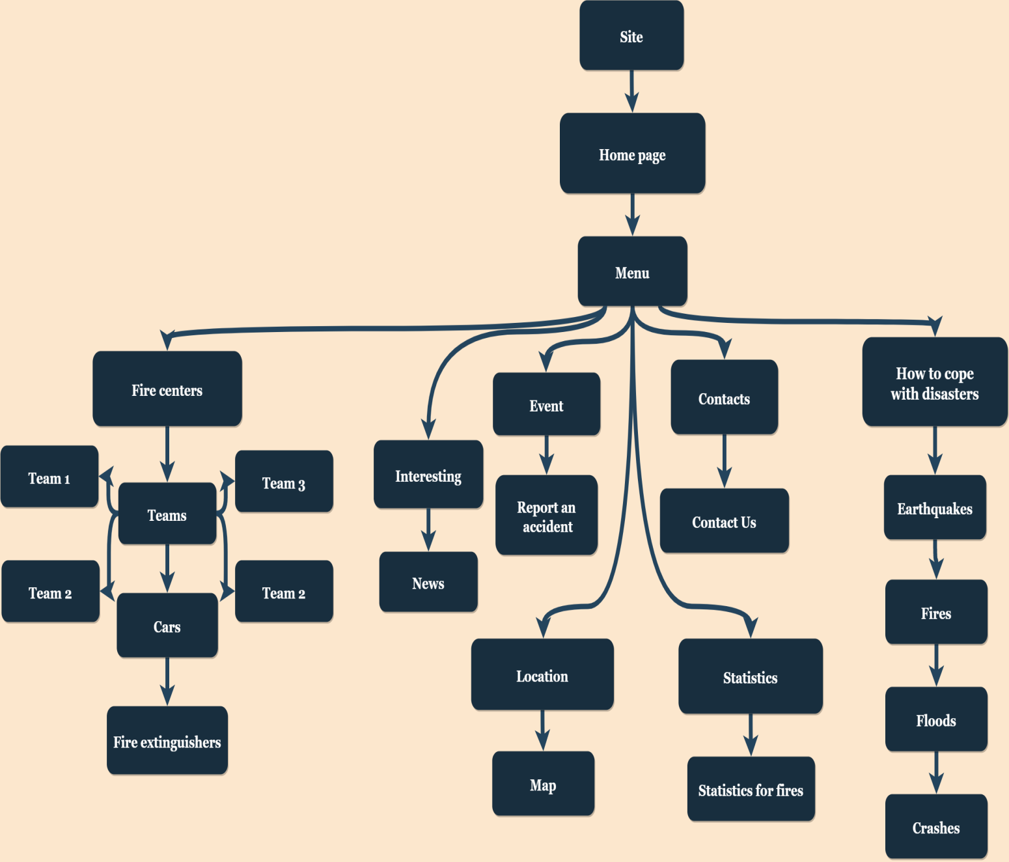**Block Diagram**

**Difficulties**

1. Problem with choosing the final design.
2. We had problems choosing the specific colors for the site.
3. Another problem was the time range with the meetings.

**Functions**

|  |  |
| --- | --- |
| drawFirstChart() | Displays the first pie chart statistic |
| drawSecondChart() | Displays the second pie chart statistic |
| drawThirdChart() | Displays the third pie chart statistic |
| getLocation() | Gets the current GPS coordinates of the person’s device |
| displayPosition() | Displays the GPS coordinates in the html |